**main.cpp code:-**

**#include**<iostream> //header file

**#include**"lab.h" //user created header file for reusability

**using** **namespace** std;

**int** **main**() //member function

{

number n; //object n is created for class number

cout<<"the number is: "<<n.numbercomp(15,8); //message to be displayed from object n

**return** 0;

}

**lab.cpp code:-**

**#include**<iostream>

**#include**"lab.h"

**int** **numbercomp**(**int** a,**int** b); //constructor numbercomp is created

**lab.h code:-**

**#ifndef** LAB_H_

**#define** LAB_H_

**class** number //class number is created

{

**public**: //class is public

**int** **numbercomp**(**int** a,**int** b) //constructor which is public

{

**if**(a > b) //if statement

{

**return** a*b;

}

**else** //else statement

{

**return** a/b ;

}

}

}; //class is terminated

**#endif** /* LAB_H_ */

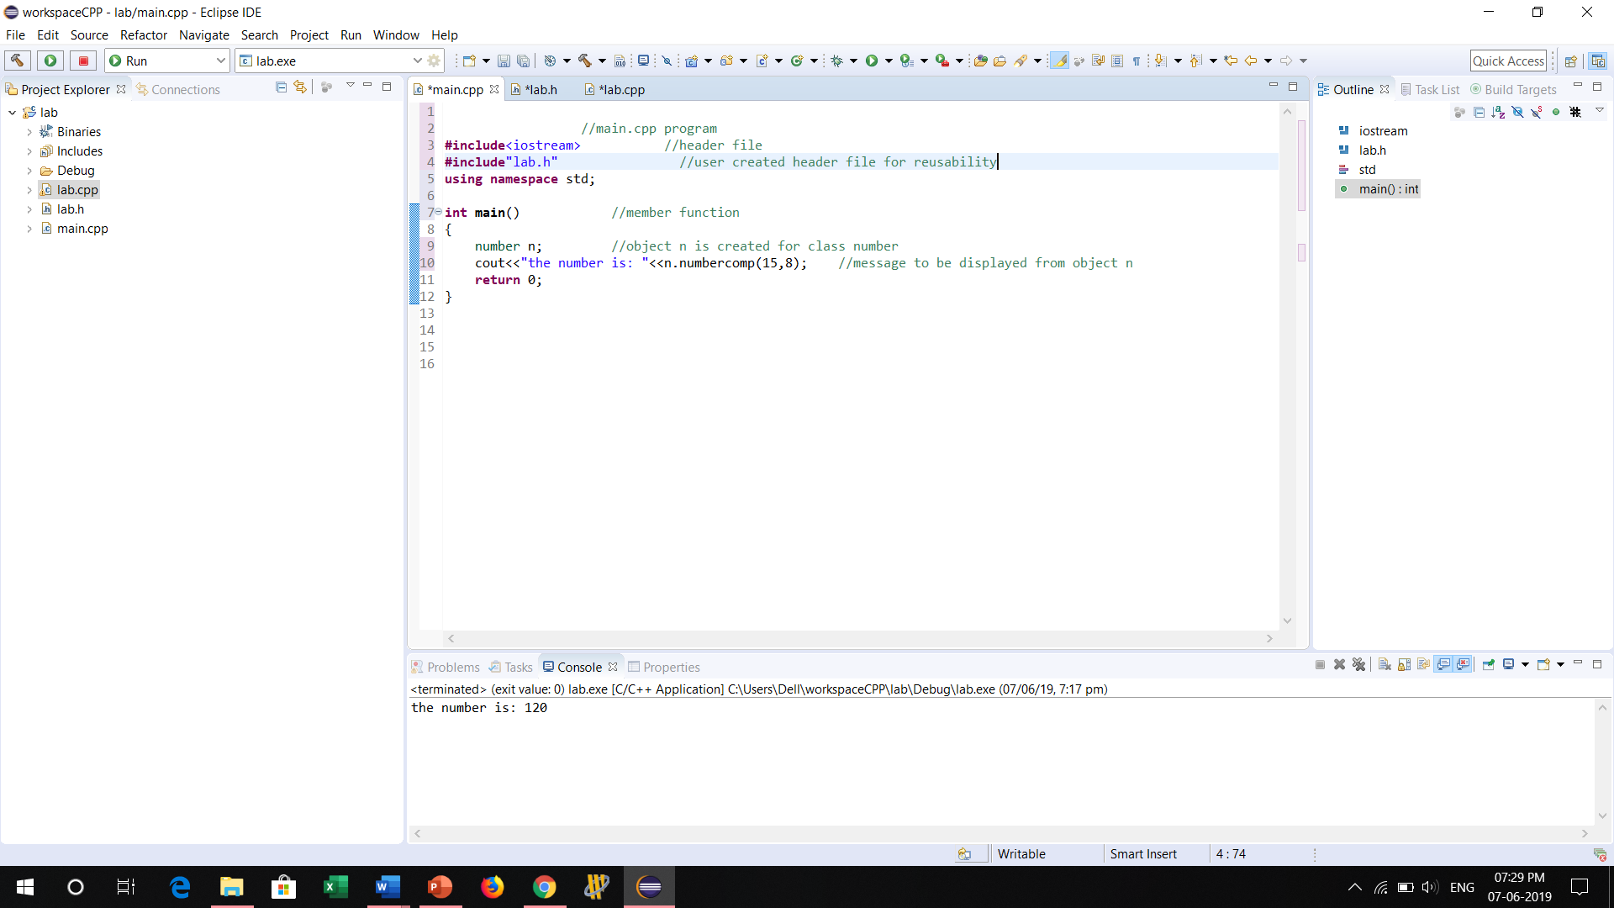

UML Diagram

|  |
| --- |
| **Number** |
| +numbercomp : Int |
| <<constructor>> + NumberComp |